Lab # 03



Fall 2024

**CSE-411L Intro to Game Development Lab**

Submitted by: MUHAMMAD SADEEQ

Registration No.: 21PWCSE2028

Section: C

“On my honor, as a student of the University of Engineering and Technology, I have neither given nor received unauthorized assistance on this academic work”

Submitted to:

Engr. Abdullah Hamid

(27 Oct 2024)

Department of Computer systems engineering

University of Engineering and Technology, Peshawar

1. Created a new Unity scene with name Lab 3
2. Created a terrain of size 100x100, height 500
3. Set height of terrain to 250 (move to this height)
4. Created mountains on one end of the terrain
5. Then Created a path in Mountain

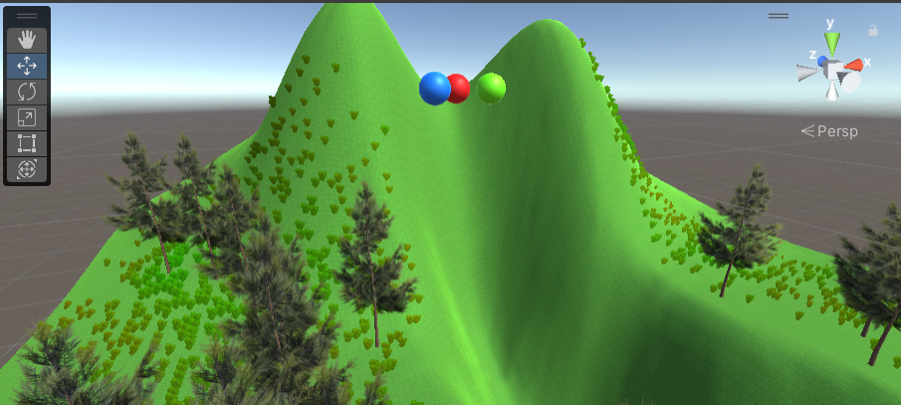

1. Created a few small spheres with different colored materials
2. The spheres was suspended on top of the path when the game plays they roll down the path
3. The spheres have Rigidbody and bouncy physics
4. On the other end of terrain create a forest with grass and flowers

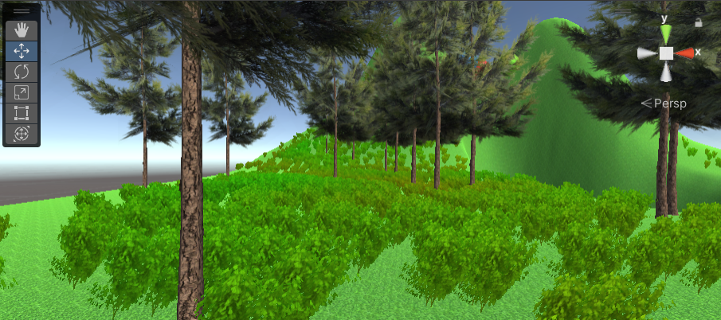

1. Created a wind zone so it could look livelier